**Project Title : Customer Care Registry Project Design Phase-I** - **Solution Fit Template** **Team ID:** PNT2022TMID52279

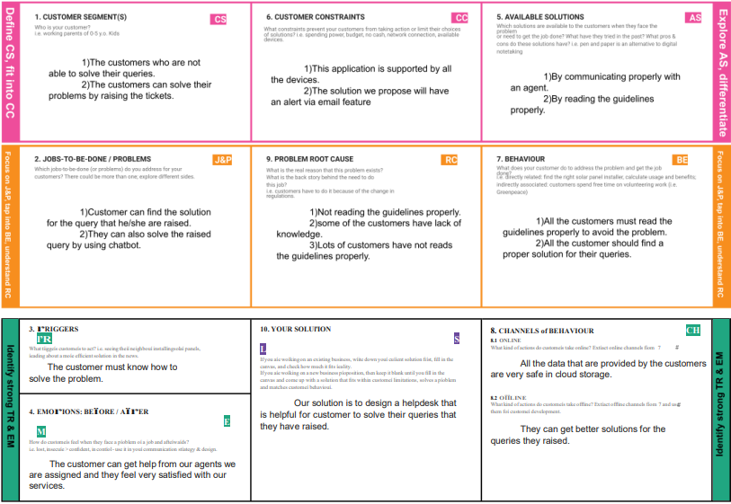

**Identify song TR & EM**